**TABLE OF SPECIFICATIONS FOR EXAM QUESTIONS**

**University of Liberal Arts Bangladesh**

**Department: Computer Science and Engineering (CSE)**

**Mid-Term Examinations, Semester: Fall 2019**

**Program: B.Sc. in CSE**

**Course Code: CSE104 Course Title: Structured Programming LAB Credit Hr: 3**

**Time: 1Hour Total Marks: 20**

**Name & Designation of the Examiner: Satyaki Das |Lecturer**

**Learning Outcomes (CO):**

|  |
| --- |
| 1. Basicknowledge of structured programming terminologies to **develop** problem-solving skills, **produce** quality code and ability to **handle** possible errors during program execution |

***Levels in Bloom’s Cognitive Domain:***

***C1: Remember C2: Understand C3: Apply C4: Analyze C5: Evaluate C6: Create***

|  |  |  |  |  |  |  |  |
| --- | --- | --- | --- | --- | --- | --- | --- |
| **Question No.** | **Learning Outcomes (CO)** | **Level in Bloom’s Cognitive Domain along with Allocation of Marks** | | | | | |
|  |  | **C1** | **C2** | **C3** | **C4** | **C5** | **C6** |
| 1 | 1 |  |  | 5 |  |  |  |
| 2 | 1 |  |  | 5 |  |  |  |
| 3 | 1 |  |  | 5 |  |  |  |
| 4 | 1 |  |  | 5 |  |  |  |
| **Total Allocation of Marks** | **20** |  |  | 20 |  |  |  |
|  |  |  |  |  |  |  |  |
| **Question No.** |  | **Learning Outcome** | | | | | |
|  |  | **CO1** |  |  |  |  |  |
| 1 |  | 5 |  |  |  |  |  |
| 2 |  | 5 |  |  |  |  |  |
| 3 |  | 5 |  |  |  |  |  |
| 4 |  | 5 |  |  |  |  |  |
| **Total Allocation of Marks** | **20** | 5 |  |  |  |  |  |

**Signature of the Examiner Date:**

**Department of Computer Science and Engineering**

**University of Liberal Arts Bangladesh**

**Final Examination (Fall 2019)**

**Course: Introduction to Computer Studies (CSE 101)**

**Section: 9 --- Duration: 2 Hour**

**____________________________________________________________________________________**

**PLEASE ANSWER ALL QUESTIONS. Total 40 Marks**

**QUESTION 1 (5 Marks)**

Draw a flowchart to find the smallest among $n$ different numbers entered by user.

**QUESTION 2 (5 Marks)**

Convert the following decimal value to its binary equivalent and show all the calculations while performing the conversion:

$${\left(BED\right)}_{16}={\left(????\right)}_{8}$$

**QUESTION 3 (10 Marks)**

Following is pseudocode snippet of a computer program:

percentage: number

if percentage > 59

then

if percentage > 69

then

if percentage > 79

then

display "A"

otherwise

display "B"

otherwise

display "C"

otherwise

display "F"

Predict the output for the following cases:

1. percentage = 64
2. percentage = 72

**QUESTION 4 (10 Marks)**

Write a C program which takes an alphabet from the user and displays whether that alphabet is lowercase or uppercase.

**QUESTION 5 (10 Marks)**

Write the C program for the following flowchart:

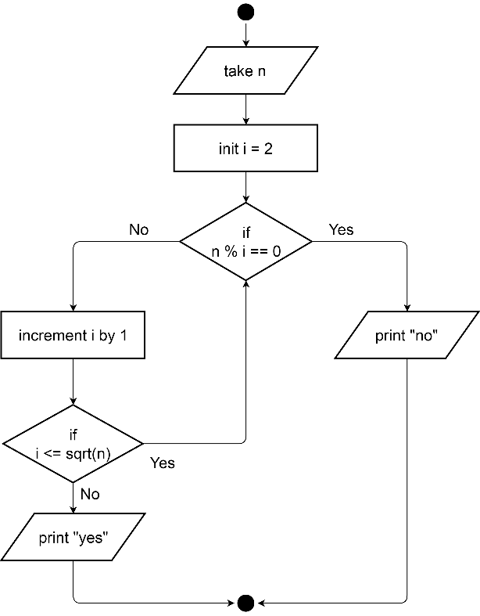

**\*\*END OF QUESTIONS\*\***